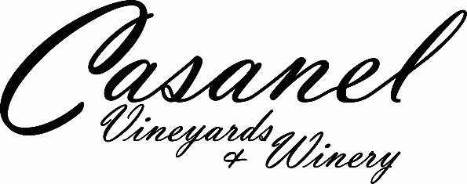 2022 Chardonnay
Estate Middleburg AVA

WINEMAKING NOTES

Our Chardonnay is made from 100% estate grapes from Block H at Casanel Vineyards. After hand-harvesting and sorting in the vineyard, our grapes were gently transported into small lugs and then stored for one night in a cold room. The day after, the grapes were sorted again on a sorting table before pressing. Cold-settling occurred for one night, followed by stainless steel tank fermentation. The first stage took place after racking the clarified juice into the fermentation vessel and was inoculated with VL2, our typical Saccharomyces cervisiae yeast, and the normal procedure for alcoholic fermentation was carried out in the single stainless-steel tank.
Following fermentation, the wine was aged half in stainless steel and half in oak barrels (one new Ana Luna and Vicard Disctinction French oak barrels; neutral barrels from Seguin-Moreau Elegance, Vicard Distinction and Sansaud
In May-June, we proceeded to protein stabilize and cold stabilize before hand-bottling on the Estate on May 18th 2023.

TASTING & FOOD PAIRING NOTES

Lemon curd – pineapple – white blossoms – tropical fruits – touch of oak for a creamier finish
Pairs well with a variety of chicken dishes, seafood, cream-based dishes, hard and soft cheeses

PRODUCTION DETAILS

Vintage Year: 2022
Vineyard: 100% Block H at Casanel Vineyard
Estate Appellation: AVA Middleburg
Composition: 100% Chardonnay Clone: French 76NC. Rootstock: 101-14, planted May 15, 2007
Average Vine Age: 16 years

Harvest Date: September 10, 2022
Bottling Date: May 18, 2023
Fermentation: 100% Stainless Steel
Yeast: VL2
ML: None
pH: 3.47
Alcohol: 12.5% vol.
Residual Sugar: 0 g/l in glucose-fructose
Aging: 60% Stainless steel, 40% barrel aged
Aging Time: 7 months
Cases Produced: 116 cases
Cellaring: Enjoy it now to 2026–Drink it while young and fresh (light-medium body wine)

